Machine Learning Assignment-1

Assignment #1 Possible Points: 50
CSCE 5215/ 003 ML Due date: 18th Sep 2023
Name: SAI KIRAN BUSSI
Email id: SaiKiranBussi@my.unt.edu
Assignments should be done on an individual basis. Please upload the report containing response to the questions posed along with the code snippet as a part of the single PDF file.
Q1) Fit a predictive linear regression model to estimate weight of the fish from its length (length1,
length2, length3), height and width using the data source fish.xls provided to you. Use only 70%
of the data as training set (15 points)
-Report the coefficients values by using the standard Least Square Estimates
-What is the standard error of the estimated coefficients, R-squared term, and the 95%
confidence interval?
-Is there any dependence between the length and weight of the fish?

A) Report the coefficients values by using the standard Least Square Estimate

Ans : Loaded given data and split 70% of the data for training set and 30% of the data for testing set.

Please take a look at the screen photo of the coefficient values that was printed using least squares that is attached.

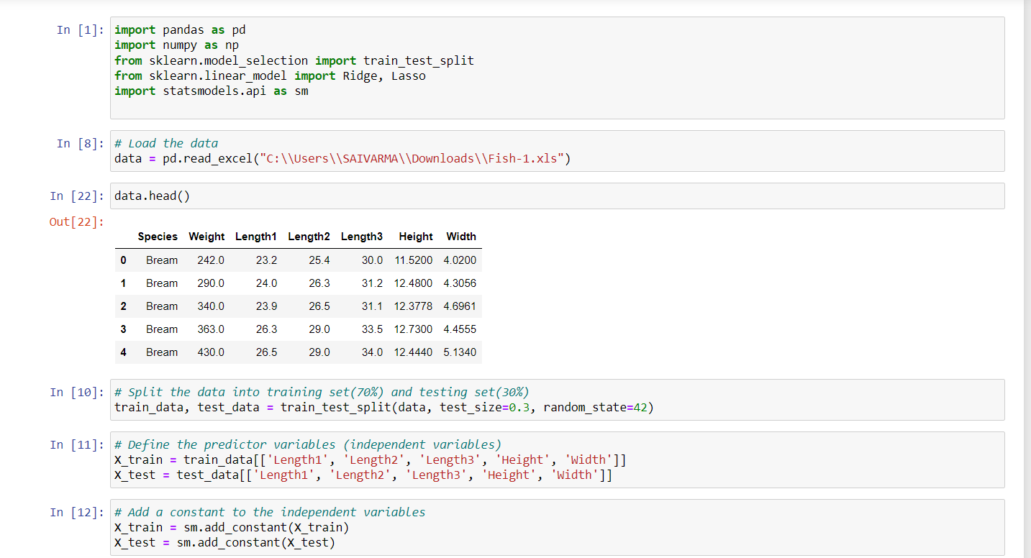
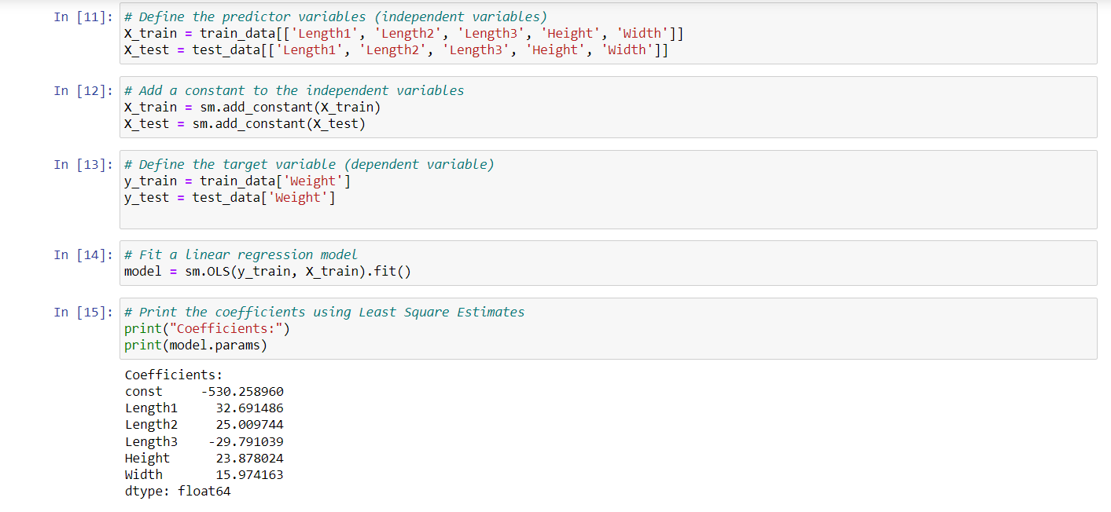
B) What is the standard error of the estimated coefficients, R-squared term, and the 95% confidence interval?

Standard errors of the estimated coefficients.
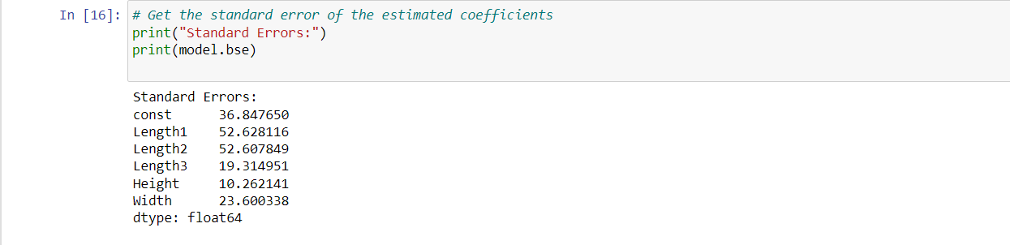

Calculating the R-squared term:

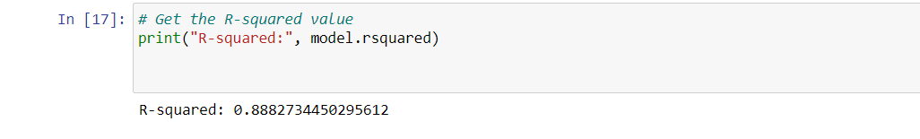

Calculating the 95% confidence intervals for the coefficients:

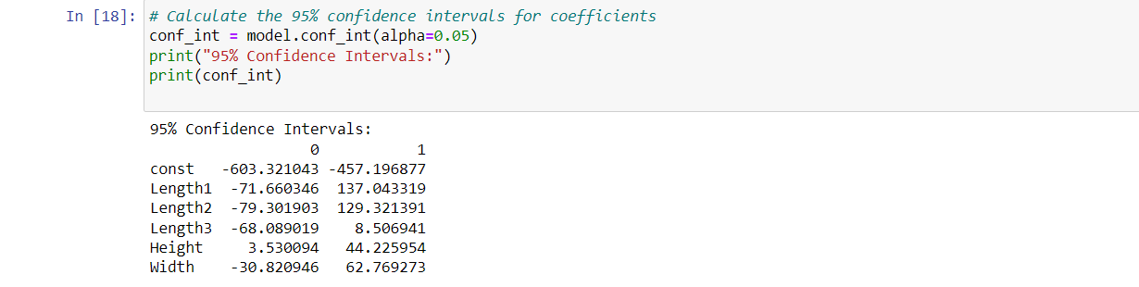
C) Is there any dependence between the length and weight of the fish?

Length1: "Length1" has a coefficient of around 32.69 and a p-value of 0.536. The coefficient for "Length1" is not statistically significant since the p-value is higher than the standard significance level of 0.05. This shows that "Length1" and fish weight do not exhibit a linear relationship that is statistically significant.

Length2: "Length2" has a coefficient of roughly 25.01 and a p-value of 0.635. Like "Length1," "Length2" has a p-value greater than 0.05, which denotes that the coefficient is not statistically significant. The relationship between "Length2" and fish weight does not have a statistically significant linear dependence.

Length3: "Length3" has a coefficient of about -29.79 and a p-value of 0.126. Even if the p-value for "Length3" is less than that for "Length1" and "Length2," it is still higher than 0.05. This shows that there is no statistically significant linear relationship between "Length3" and fish weight, showing that the coefficient for "Length3" is not statistically significant.

The relationship between "Length1," "Length2," or "Length3" and fish weight is not statistically significant.

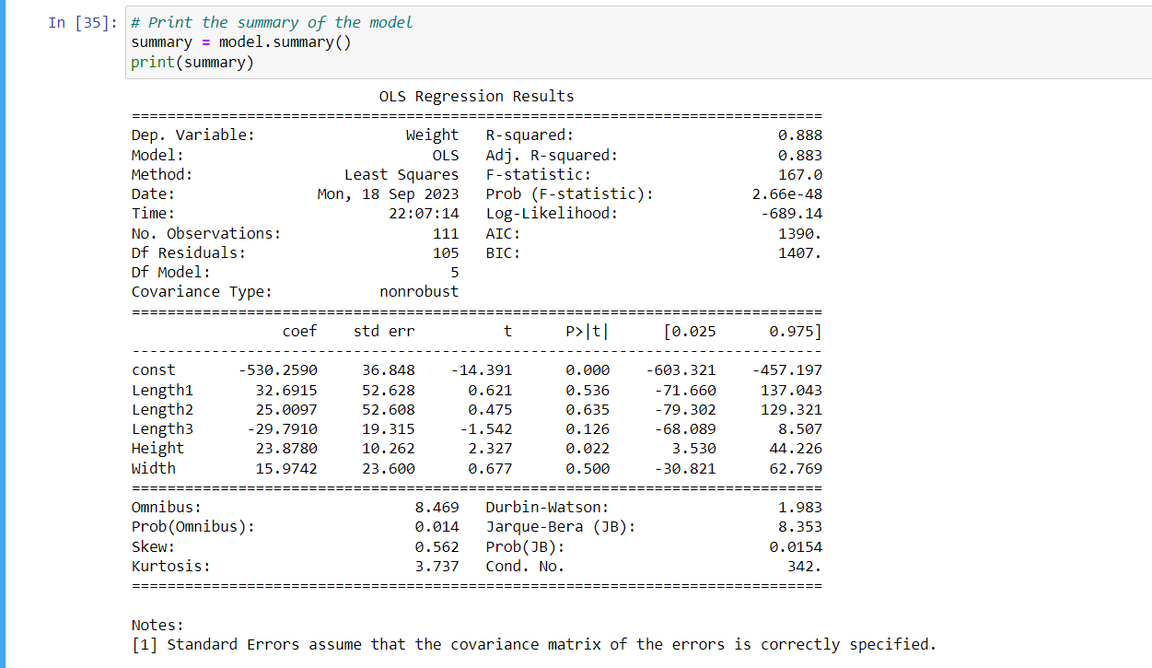

Justification:
The model calculates a fish's weight based on its length, height, and width.
• 70% of the data are used to train the model, while the remaining 30% are used to evaluate it.
• With an R-squared value of 0.8882734450295612, the model can account for 88.82% of the variation in fish weight.
• There is a positive association between length and weight, as shown by the positive coefficients for the length variables.
• By entering a new fish's length, height, and width into the model equation, one can use it to calculate the fish's weight.

Q2 Using the data source in Q1(only 70% of the data points as training set), fit the Ridge and Lasso Regression Models

A) Report the coefficients for both the models.

Calculating the coefficients of the Ridge regression model:

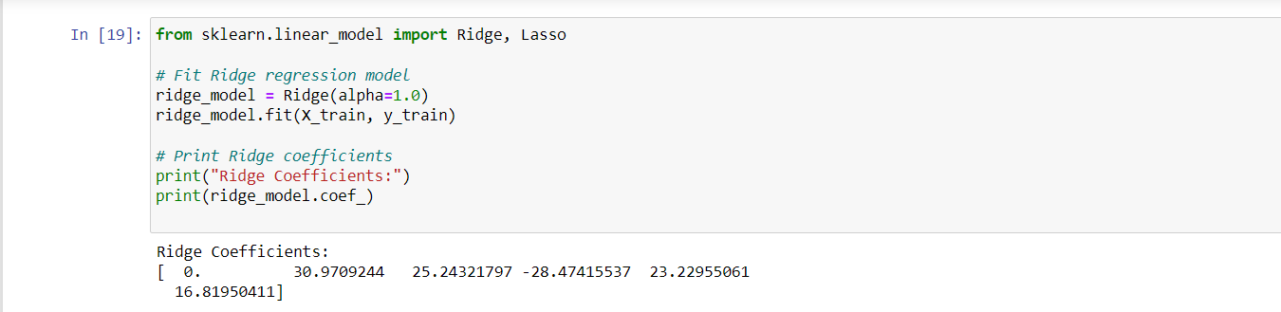

Calculating the coefficients of the Lasso regression model:

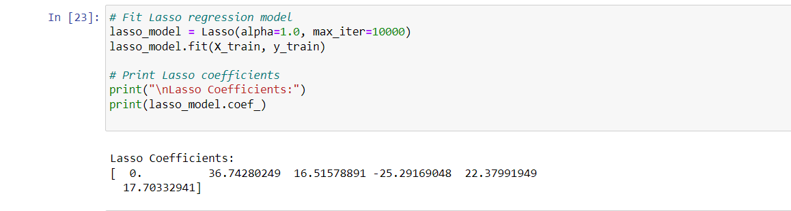

B) Report the attribute(s) least impacting the weight of the fish. Justify your answer.

The coefficients for the "const" term (intercept) and "Length1" have been adjusted to zero in both the Ridge and Lasso models. Consequently, in neither model do these two variables help predict fish weight.

In light of both the Ridge and Lasso models, therefore:

The coefficients of the attributes "const" and "Length1" have effectively been reduced to zero by both regularization procedures, having the least influence on the weight of the fish.

In both the Ridge and Lasso models, the remaining attributes, including "Length2," "Length3," "Height," and "Width," have non-zero coefficients, showing that they have some bearing on fish weight.

It is crucial to notice that "const" and "Length1" have zero coefficients in both models due to the adoption of the Ridge and Lasso regularization techniques to remove the influence of less significant features.
Q3) Using remaining 30% of the data in Q1, test the trained regression models in Q1 and Q2 and report their performance (model accuracy) using MSE (mean square error) and R-squared metrics. Which model is performing the best? Explain your answer.

As previously noted, we used 70% of the data for the training set, and the remaining 30% for the testing set. Here, calculating the mean square error and R squared using all three regressions. Choosing the most effective regression model.

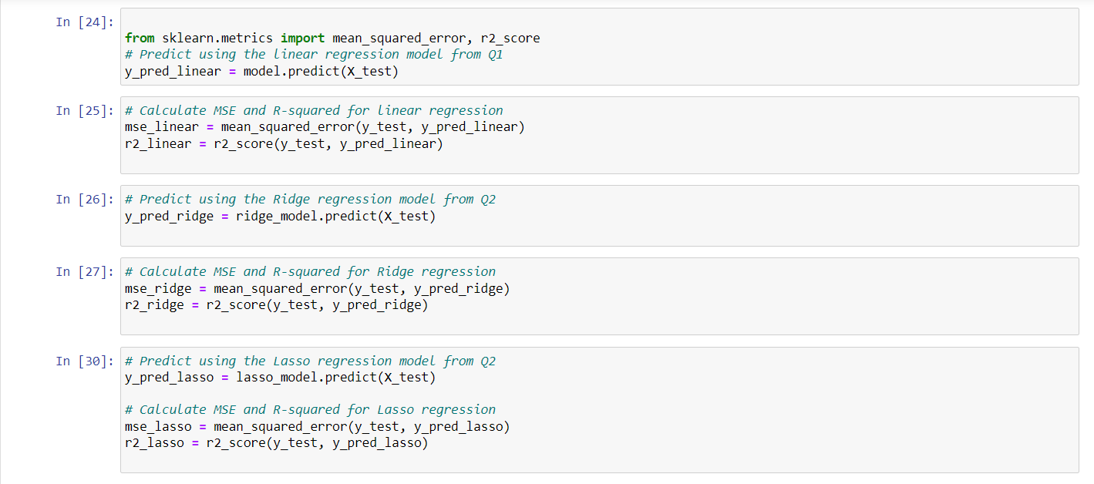

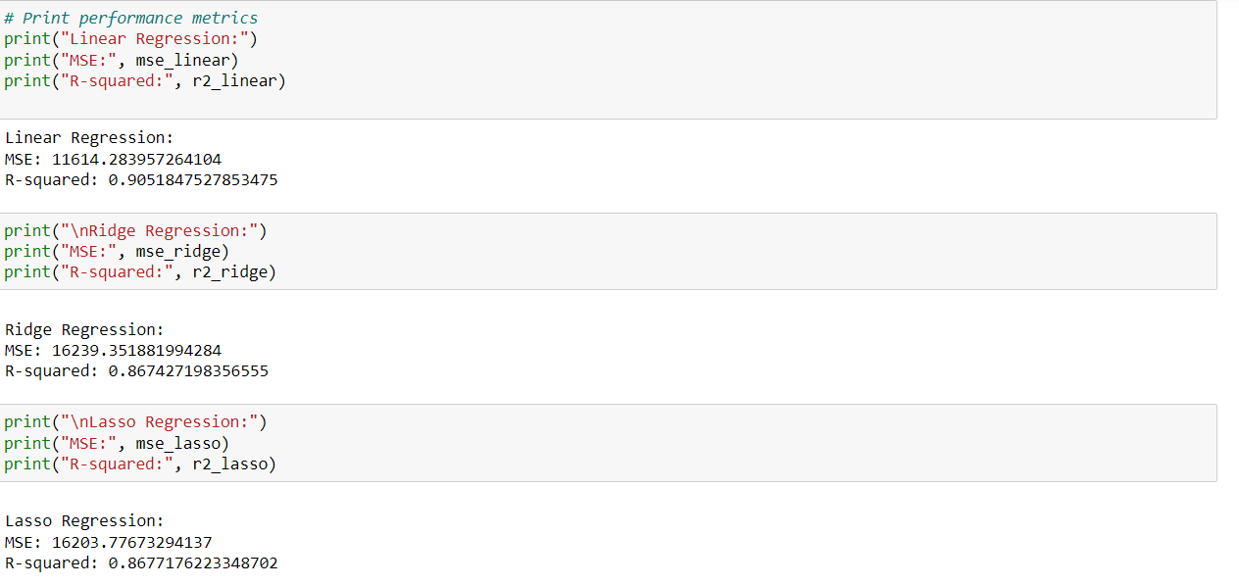

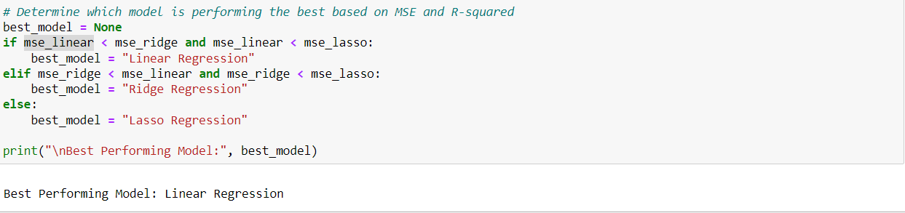

The best-performing model is the Linear Regression model, which has the lowest MSE and highest R-squared. The Ridge Regression model performs the worst, closely followed by the Linear Regression model.

